Bringing the training to life
Courier Training Framework: Bringing the training to life
Introduction
This guide accompanies the Courier Training Framework (a tool for developing and delivering courier training, put together as a basis for promoting best practice in the museum and gallery sector).
Following two years of use in the sector, we wanted to share some of the creative and dynamic ways in which people have used interactive sessions to bring the training to life. If you have any further examples you would like to share, please contact us using the details in the main framework document.

Contents:
Case Study 1: National Museums Scotland, ‘Getting hands on’ working with other disciplines
Case Study 2: Museum of London, ‘At the cargo shed’ role play

Case Study 1: National Museums Scotland ‘Getting hands on’
By Lyn Stevens, Registrar, National Museums Scotland
National Museums Scotland incorporated the Courier Training Framework into their existing training offer after it was launched in 2017. Evaluation of the first training session indicated that trainees would find practical exercises beneficial:
“I think the workshop would have benefited from more practical exercise in the first half of the day related to packaging and condition checking.
It would be great to get a practical demonstration of how to go about packing up objects prior to transfer. If couriering back from other museums it might be that we have to repack objects and it would be wonderful to learn how to do it from professionals.”
We train National Museums Scotland staff and colleagues from across the Scottish museums sector together, in one session, so the training can’t be specifically about National Museums Scotland procedures. With this in mind, between preparing the loan and the journey sections, we added a session with our conservators to share knowledge of object condition checking and packing.
In this section, the conservators present different types of packing and condition reports that could be used depending on the types of objects and journeys involved.
Secondly, the trainees are given a practical exercise to condition check and pack an object. The trainees are split into three groups and each group is given different types of packing materials. After each object has been packed, each group is asked to talk about what they wrote in the reports and why they chose to pack the object how they did. The conservators then test the packing by dropping the box/crate on the floor (we use handling objects!) and discuss how packing could be improved, what worked well etc.
When both internal and external colleagues sign up for the courier training, they frequently express a wish to gain knowledge of airport procedures and international loans. As part of the journey section we invite a shipping agent from one of the established fine art shippers to present. This means the information given is up-to-date and given by an expert ‘in the field’. Feedback on these presentations has been very positive.

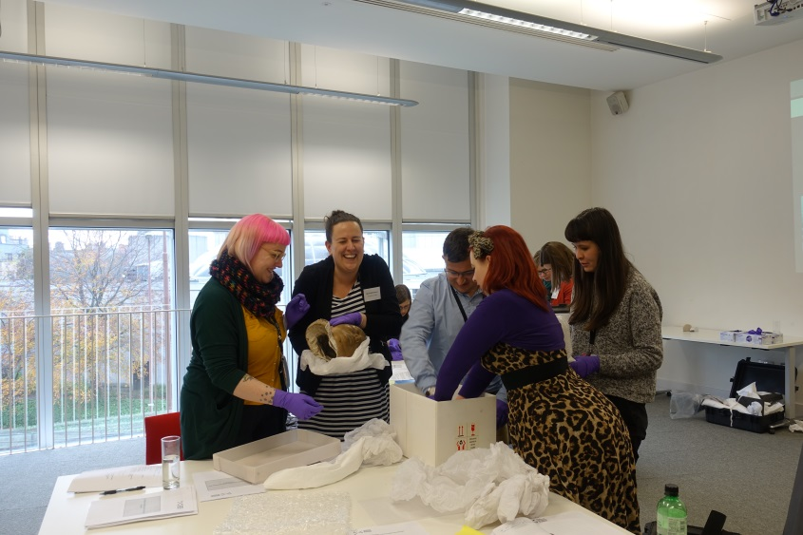
Testimonials from Training session November 2019:
“I now feel comfortable being asked to courier an object and confident I would be able to complete the work and know the right questions to ask of the lending and borrowing institutions and what is expected of me.”
“I know what to expect/what would be expected of me should I courier an object .”
“Following the workshop I was involved in a couriering job between my place of work and a conservation studio in Edinburgh. I was able to use what I had learned from the workshop (having not couriered before) to ensure proper practise and the collections safety between the two locations.”
“Very much enjoyed the day, especially the practical sessions and scenarios.”
“This was splendidly educational and also (gasp) entertaining. The bit from the shipping agent was fascinating. Apparently I've always wanted to know how crates fit into the cargo hold.”

Case Study 2: Museum of London ‘At the Cargo Shed’
By Kathy Richmond, Senior Registrar, Museum of London
The team at the Museum of London wanted to give their trainees more exposure to the practises they might encounter in the cargo shed as this is an area where staff have little chance to gain experience before their first trip, and often felt anxious about. In order to share this learning they came up with a role play scenario.
After a short PowerPoint/interactive session discussing the theory of palletisation, this role play is introduced after the lunch break when trainees benefit from the opportunity to do something more active or hands on.
Trainees are asked to act collectively as the courier, the registrar facilitating the courier training day plays the role of the fine art transport agent rep, and the collection care officers (who specialise in object handling and transportation at the museum) play the role of the cargo shed staff who will conduct palletisation.

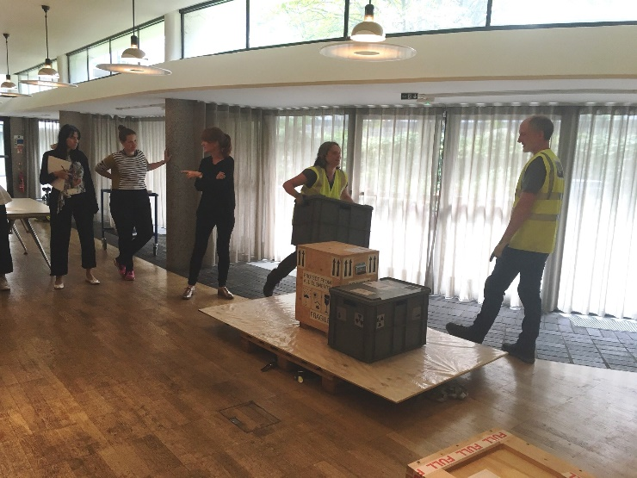
The ‘courier’ (trainees) gather next to a makeshift pallet and their museum crate is about to be prepared for transit/palletisation. The ‘agent’ (registrar/trainer) explains that we are now about to palletise, and that the ‘courier’ should communicate their requirements during the process in the way they feel is best for achieving a good result. The ‘cargo shed team’ (collections care officers) enter and begin palletisation.

We hope that the ‘courier’ will communicate clearly and respectfully, asking for help from the ‘agent’ to adjust requirements and discuss options if needed.
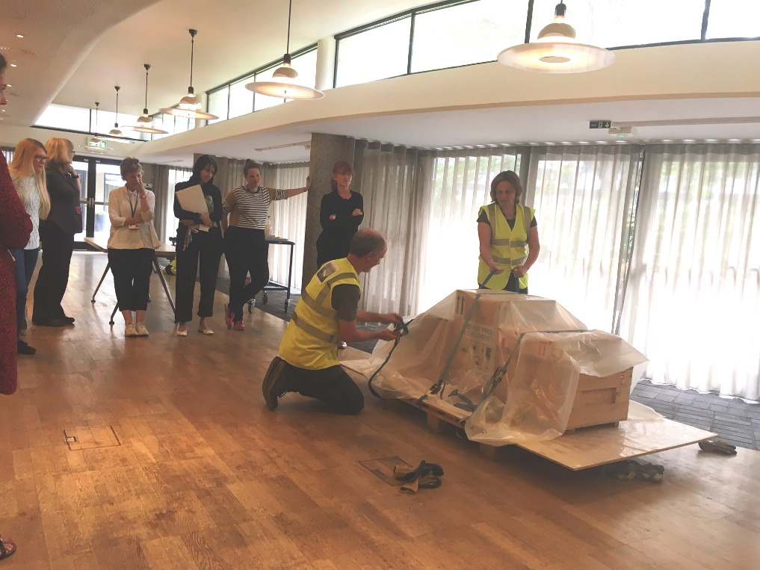
Julie Fuller and Dave Ramage, Collections Care Officers at the Museum of London, playing the roles of cargo shed staff, tying off the cargo on the pallet, whilst trainee couriers observe.

Palletisation begins and the ‘cargo shed team’ do the following things which we hope that the ‘courier’ will spot and adjust via constructive communication:
- Attempt to begin with a sheet of polythene with rips/holes in it
- Load incompatible cargo (hazardous materials etc.)
- Tie straps both too tight and too loose, or only in one direction
- Stack or load precariously
- Leave the area to take a break during palletisation
- Bring ‘priority’ cargo (nuclear machine part, coffin, etc. as appropriate)
- Load the museum crate at the edge of the pallet
At the end of the exercise, we ask the ‘courier’ if they think they should have done anything differently in hindsight, then also ask the ‘cargo shed team’ for their feedback. Often basic things like remembering to introduce themselves to the team and ask for their names get missed out. We also ask them how they found the exercise, noting often that responses vary from ‘fun’ to ‘stressful’ and ‘slow’, and then have an opportunity to talk more about the pressures of working in the cargo shed environment and how the role play differs from real life. We also make clear that in reality cargo shed teams and reps are usually very professional.

